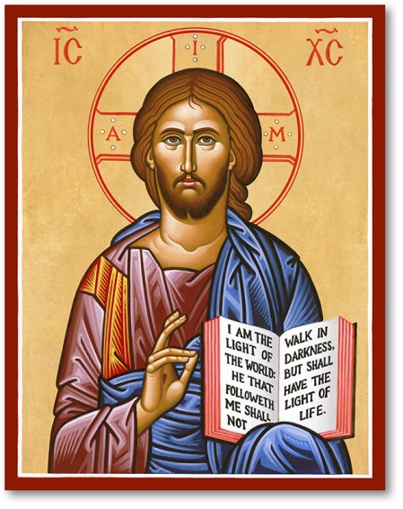
Annunciation Melkite Cathedral
7 VFW Parkway, West Roxbury, MA 02132

Religious Education Registration Form

2023-2024

Last Name _________________________________________________________________

Mother’s First Name _________________________________________________________

Father’s First Name___________________________________________________________

Home Address ______________________________________________________________

Emails _________________________________ __________________________________

Home Telephone ____________________________________________________________

Cell Phones_____________________________ _________________________________

Name of Child _______________________Date of Birth __________Age ____ Grade ____

Name of Child _______________________Date of Birth __________Age ____ Grade ____

Name of Child _______________________Date of Birth __________Age ____ Grade ____

Name of Child _______________________Date of Birth __________Age ____ Grade ____

Name of Child _______________________Date of Birth __________Age ____ Grade ____

Allergies or other medical conditions: ____________________________________________

Parents Signature _____________________________________________________________
By signing I hold the Annunciation Cathedral and its clergy, associates, volunteers, teachers, employees, and affiliates
harmless for any injury or damage that my child(ren) may suffer as a result of any activities at Sunday School.

Suggested Donation: $25.00 per child. Family with 2 or more children: $50.00 total.

For Rel Ed Use only:
Registration Fee received___ Amount ___________ Initials _______ Today’s Date _______

